# Part 2: Transportation Analysis

## Environment Impacts

Fig. 9 Contribution on transportation to the atmosphere pollution. Source http://www.ec.gc.ca

Several specialists studied the problems related to the transportation system. This industry seems to be an important factor in the CO2 emissions. Even if the number decreased during the lasts years, the percentage of 27% remains too high.

The part of atmosphere pollution due to the transportation is very high in the big cities. For these areas, we consider that the transportation by road is the first responsible of emission of NOx and PM10 particles. The process of emission of those particles is:

* The VOC (Volatile organic compounds): those particles are emitted directly from the exhaust of cars.
* NOx: some of those particles are emitted by the engine and some others are produced by chemical reactions in the atmosphere due to the NOx emitted.
* PM10 and PM2.5 are emitted or created by the VOCs. There volatility is due to the traffic.

In this part we are going to calculate the ecological impact of using carpooling. We are limiting our study of ecological impact to the CO2 emission during the travels. Our statistics are collected from the last ENTD (a French study which is made each 10 years to know how French people are traveling). The study was made with a sample of 20200 representative households of the national (France) tendency.

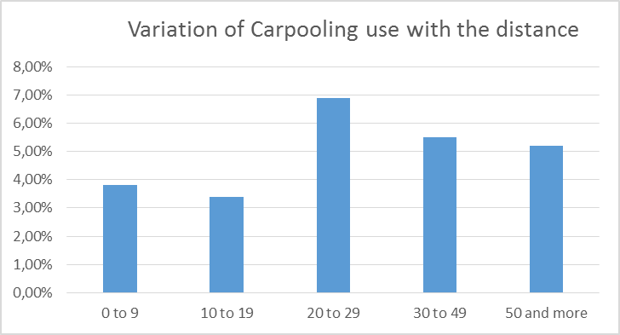

Those figures are showing that the most important use of carpooling is related to travels between 20 and 30 km.

Fig. 10 Variation of Carpooling use with the distance. Source ENTD 2010

### 

Fig. 11 Variation of occupation rate for a type of travels. Source ADEME 2013

From these diagrams, we learned that the mean distance of people is around 14.7km. This figure is going to allow us to calculate the rejected quantity of CO2 and the the potential of reduction.

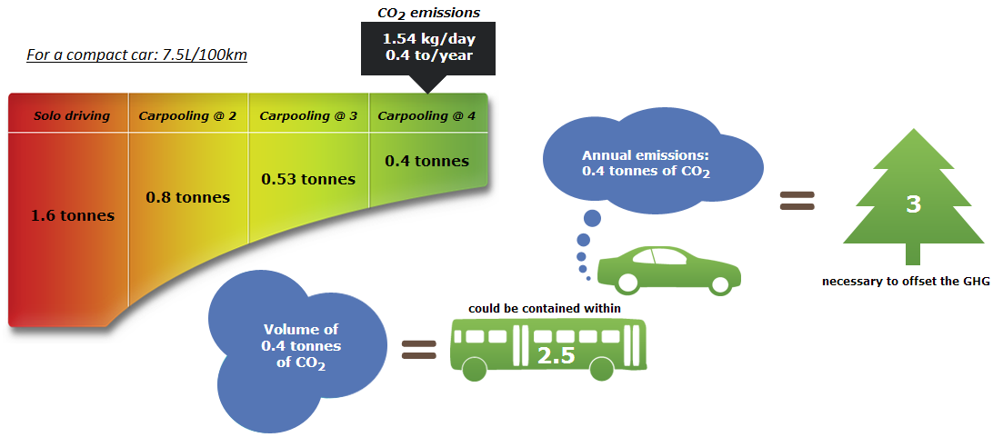Fig. 12 CO2 Emissions for different scenarios with small car. Source Canadian ministry of transportation

We learn from ENTD’s figures that, the mean distance between house and work place is 14.7km.

This simulation is made for:

* round trip
* 5 working days per week and
* 52 working weeks in the year.

### 

## Transportation Cost

The high cost of transportation is the first motivation for people to carpool. As we saw in the different figures in the previous parts, the environmental impacts are making people to think about the alternative transportation solution. But the figures also showed that the price of oil is directly related to the number of carpoolers. In this part, we are going to estimate the possible money saving for a user.

According to the data that we collected from SOeS “comptes des transports” July 2014, in France, the mean consumption is 6.2l/100km for a diesel car and 7.5l/100km for the others.

Then, this same source and the national study about mobility provide the following data:

|  |  |  |
| --- | --- | --- |
| Car type | Diesel | Gasoline |
| Mean fuel consumption | 6.2 L/100km | 7.5 L/100km |
| Mean kilometers travelled | 15477 km/year | 8225 km/year |
| Proportion of each car in France | 62% | 38% |
| Mean fuel price in France | 1.389€/L | 1.602€/L |
| Occupation rate of a car | 1.2 person per car | |

So we can estimate the annual fuel cost per car in France. This cost includes only the fuel cost.

$$Cost=\frac{6.2}{100}L×15477km×1.389€×62\%+\frac{7.5}{100}L×8225km×1.602€×38\% \\ Cost=1202€ per year per car$$

Knowing the occupation rate of a car, we can estimate this cost to:

$$Cost=\frac{1202€ per year per car}{1.2 person per car}=1002€ per person per year.$$

If the rate can be increased to a mean of 2 person per car, the annual cost will be reduced to 601€ per person per year which represents a reduction of 400€ per year only in the fuel costs.

(En marge)

In France, people can potentially same 400€/year by increasing the carpooling rate from 1.2 person per car to 2 person per car. This amount represents more than 30% of the average monthly salary.